# Research Unity Mecanim

I wanted to learn how to use Unity Mecanim, which is the animator inside the Unity engine. It allows me to set up and optimize my animations.

From the official website:

Mecanim provides:

* Easy workflow and setup of animations on humanoid characters.
* Animation retargeting - the ability to apply animations from one character model onto another.
* Simplified workflow for aligning animation clips.
* Convenient preview of animation clips, transitions and interactions between them. This allows animators to work more independently of programmers, prototype and preview their animations before gameplay code is hooked in.
* Management of complex interactions between animations with a visual programming tool.
* Animating different body parts with different logic.

I used tutorials to learn the basics of this tool and tried out things myself to gain a better understanding of how to use it.

I created a Unity test scene to practice different aspects of the tool. I added a commented script, so that I make sure I understand what is really happening in that piece of code.

## Basics – setting up a character

#### Rig > humanoid > create from this model (if ticked it was automatically configured!

**Optimize game Objects – on**

Unity creates many empty game objects to represent all bones and joints, that drags down the performance and is most often not needed.

However, if certain body parts have to be influenced apart from the others, add them in the ‘extra transforms to expose’ field

**Inspector tab**

#### Mapping:

### Representation of how Unity lays out the character and its bones.

### Solid circle meaning necessary, dotted circle optional

### Rearrange, add or delete connections

#### Muscles:

* Preview of the overall reach of muscles
* Preview grouped by body areas
* Additional settings

Not animation! It’s setting maximum ranges for muscle for the character.

**Done!**

This covers everything to set up the character. Moving on to some features of Unity Mecanim.

## C# Character Controller

I also learned how to script a character controller and set up blend trees. Here you can see some of my code I used to make the character walk forward, left, right and backwards.

I added two floats inside the animator that I used to set up and define the animation behavior in the ‘walk’ blend tree.

Once the blend tree was set up I only needed to add in my C# script.

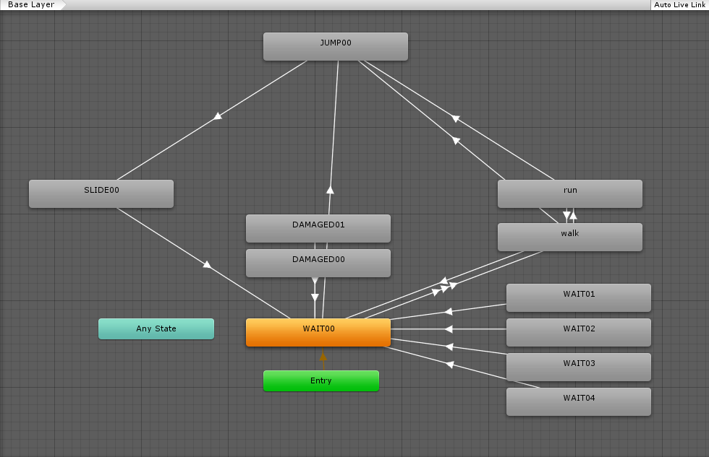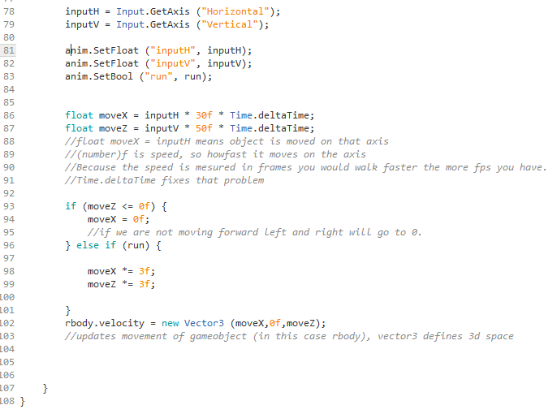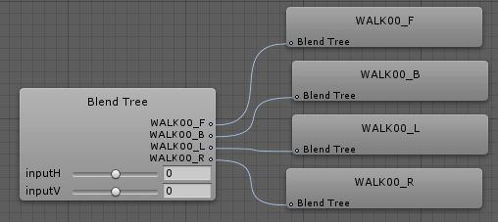

## Avatar Masks

Avatar masks allow me to change animations for certain body parts while the rest of the body keeps playing other animations.

You are able to choose which parts of the body get affected by this animation. After choosing the body parts you can create a new animation layer with its own states and blend trees.

After setting up the layer you only need to assign the avatar mask to this layer. You can turn avatar masks on and off per code.

sources:

<https://docs.unity3d.com/462/Documentation/Manual/MecanimAnimationSystem.html>

<https://unity3d.com/de/learn/tutorials/modules/intermediate/live-training-archive/character-animation-setup?playlist=17099>

<https://www.youtube.com/watch?v=wdOk5QXYC6Y>